**Day -01**

**Introduction**

**Generic printf statement :**

int printf(const char *-format,…);

char * is the dynamic string creation

-format is a reference for the pointer

… is variable argument / takes n number of arguments

**Executable printf statement is**

Printf(control str,args);

* **What is an operating system(OS):**

An **Operating System (OS)** is a software that acts as an interface between computer hardware components and the user. Every computer system must have at least one operating system to run other programs. Applications like Browsers, MS Office, Notepad Games, etc., need some environment to run and perform its tasks.

The OS helps you to communicate with the computer without knowing how to speak the computer’s language. It is not possible for the user to use any computer or mobile device without having an operating system.

[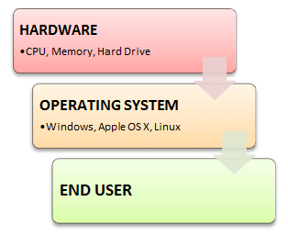](https://www.guru99.com/images/1/011819_0753_OperatingSy1.png)

**Types of Operating System (OS)**

Following are the popular types of OS (Operating System):

* Batch Operating System
* Multitasking/Time Sharing OS
* Multiprocessing OS
* Real Time OS
* Distributed OS
* Network OS
* Mobile OS

**Functions of OS:**

1. **Process management**: Process management helps OS to create and delete processes. It also provides mechanisms for synchronization and communication among processes.
2. **Memory management:** Memory management module performs the task of allocation and de-allocation of memory space to programs in need of this resources.
3. **File management**: It manages all the file-related activities such as organization storage, retrieval, naming, sharing, and protection of files.
4. **Device Management**: Device management keeps tracks of all devices. This module also responsible for this task is known as the I/O controller. It also performs the task of allocation and de-allocation of the devices.
5. **I/O System Management:** One of the main objects of any OS is to hide the peculiarities of that hardware devices from the user.

**Features of Operating System (OS)**

* Protected and supervisor mode
* Allows disk access and file systems Device drivers Networking Security
* Program Execution
* Memory management Virtual Memory Multitasking
* Handling I/O operations
* Manipulation of the file system
* Error Detection and handling
* Resource allocation
* Information and Resource Protection

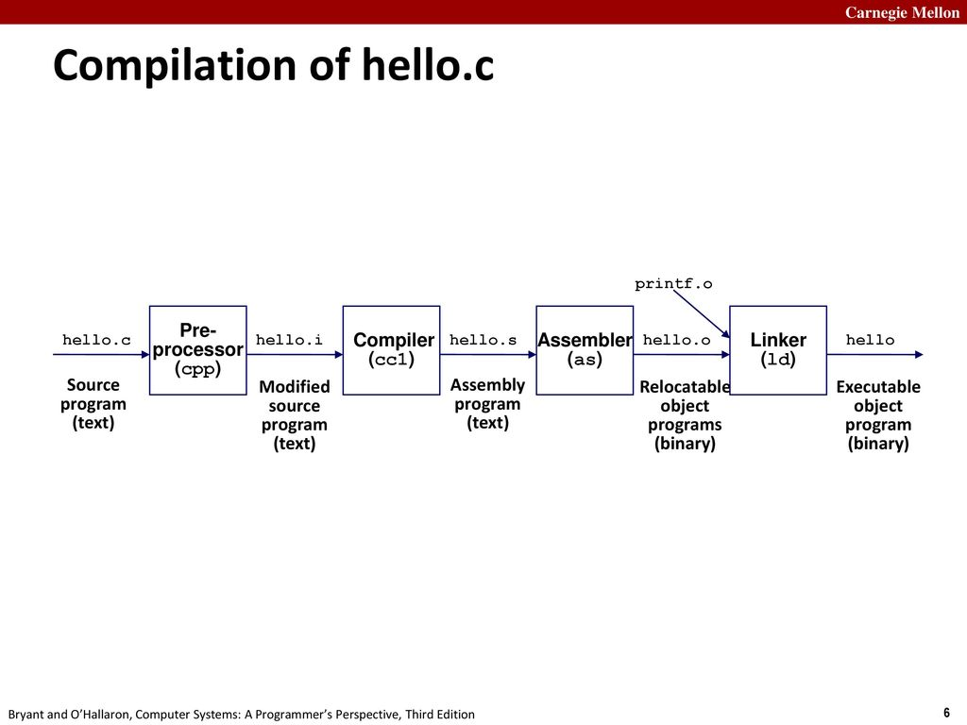

**Pre processing phase:** It includes header files and expand macros , which means exporting the libraries of the header in the pre processing stage the values are directly taken.

**Compilation phase:**Iit checks semantic and syntax errors

**Assembly phase:**Converts into binary form which is not runnable

**Linking phase:** File is ready to be loaded into the main memory .the linker establishes a link between object file and memory.

**What is Multiprocessing?**

* When one system is connected to more than one processor which collectively work for the completion of the task, it is called as multiprocessing systems.

**What is Multithreading?**

* "Multithreading is a conceptual programming paradigm where a process is divided into a number of sub-processes called as threads. Each thread is independent and has its own path of execution with enabled inter thread communication."

**What is multi tasking?**

Multi tasking operating systems allow multiple users to perform multiple tasks at the same time. The allocation of system resources such as [input/output devices](https://www.geeksforgeeks.org/input-and-output-devices/), [CPU](https://www.geeksforgeeks.org/central-processing-unit-cpu/) and [memory](https://www.geeksforgeeks.org/computer-memory/) among processes can be easily managed by multi-tasking operating system

* **Heap** is the virtual memory that is created by the dynamical allocation by using pointers
* Local variables are in the **stack.**
* Allocation of heap memory is in **pages .**
* **Structure padding** should be avoided because it takes more bytes.
* **What is Kernel?**

A kernel is the core part of an operating system. It acts as a bridge between software applications and the hardware of a computer. The kernel manages system resources, such as the CPU, memory, and devices, ensuring everything works together smoothly and efficiently. It handles tasks like running programs, accessing files, and connecting to devices like printers and keyboards.

* **What is Shell?**

A shell is a special user program that provides an interface for the user to use operating system services. Shell accepts human-readable commands from users and converts them into something which the kernel can understand. It is a command language interpreter that executes commands read from input devices such as keyboards or from files. The shell gets started when the user logs in or starts the terminal.

* **Booting process:**

Booting is the process of starting the computer

* **Init process** is the mother of all processes
* **Jobs of init are**

1.) system into multi user mode

2.)Checks the integrity of file system

3.)Modes of unix operations is called system states (or) run levels

0: shut down state

1:Administrative state

S or S : single user state

2: multi user state

6: stop and reboot state

These states are passed to init program.

* **FILES:**

Files is a collection of data.

File content are treated as series of bytes

Devices are also treated as special files.

UNIX stores all files in identical Manner.

* **File naming conventions:**

A file consists of only one Inode(Information node)

Inode structure used to maintain information about the file.

File names are case sensitive .

* **Directory:**

All the files are grouped together in the directory

Directory structure is

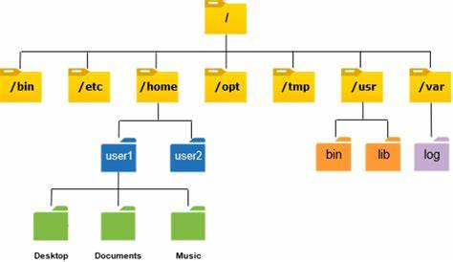

* **Links**
* **Hard links:**

Hard links behave like a physical file

Hard link adds an additional pathname to reference a single file

The rm command decrements the link count

When link count becomes zero the file is removed

Hard are applied only on files

If we delete the original file it will not effect the copy file

* **Soft link or symbolic links:**

Soft link can be applied for both files and directories

It acts as a shortcut file

If we delete the original file it will effect the copy file

‘